# Quadcopter Frame

* [FCMODEL X4 M280L Wheelbase Glass Fiber Across Mini Quadcopter Frame Kit DIY RC Multicopter FPV Drone](https://www.amazon.com/gp/product/B014KNMKF0/ref=oh_aui_detailpage_o04_s00?ie=UTF8&psc=1)
* Weight about: 156g 🡪
  + 55 g per side (x2)
  + 24g /24 connectors = 1 g
  + 10 g per top plate
  + 10 g /4 big connectors = 2.5 g

# Legs

* <https://www.amazon.com/gp/product/B00QHVVKEG/ref=ox_sc_sfl_title_1?ie=UTF8&psc=1&smid=A3Y26MC43SQCQ>
* Height:150mm.
* Weight:**18g/pcs**

# MPU-9250

* <https://www.amazon.com/Mpu-9250-Nine-axis-Attitude-Acceleration-Magnetic/dp/B00OPNUO9U/ref=pd_cart_rp_2_3?_encoding=UTF8&psc=1&refRID=BYG3BGN2TGJM5B6HS7HY>
* 0.106 ounces **(3 g)**

# Propellers

* <https://www.amazon.com/gp/product/B00Y4QNSFA/ref=oh_aui_detailpage_o00_s01?ie=UTF8&psc=1>
* 5030
* Weight: 4.5g / pcs

<https://www.amazon.com/gp/product/B00P2FX9WY/ref=oh_aui_detailpage_o00_s03?ie=UTF8&psc=1>

# Arduino

* <https://www.amazon.com/gp/product/B00P2FX9WY/ref=oh_aui_detailpage_o00_s03?ie=UTF8&psc=1>
* 0.3 ounces (9 g)

# Electric Motors

* Emax MT1806 2280KV
* KV: 2280
* Max Trust: 460g
* No. of cell: 2-3S
* Framework: 12N14P
* Propeller: 5" ~ 6"
* Length: 26.7mm
* Shaft: 2mm
* Diameter: 23mm
* **Weight: 18g**
* Wires: 9g?

Prop  Volts  Throttle   Amps   Watts   RPM    Thrust (g)  
6030  11.1   30%      1.7       12.58   8191    106  
6030  11.1   50%      2.8       20.72   9818    155  
6030  11.1   65%      3.8       28.12   11186   206  
6030  11.1   85%      6.5       48.1    13643   309  
6030  11.1   100%     8         59.2    14618   355  
6045  11.1   30%      1.9       21.09   7104    115  
6045  11.1   50%      3.2       35.52   8574    170  
6045  11.1   65%      4.8       53.28   10022   232  
6045  11.1   85%      8          88.8    11882   328  
6045  11.1   100%     9.7       107.67 12692   370

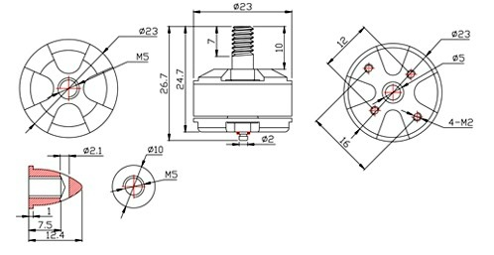

ESCs

__0_000_______________10_000________.______",_000_______________

# Batts

* <http://www.getfpv.com/lumenier-1500mah-3s-45c-lipo-battery.html>

|  |  |
| --- | --- |
| **Length** | 88 mm |
| **Width** | 35 mm |
| **Height** | 22 mm |
| **Weight** | 125g |
| **C-Rating** | 45c - Burst 90c |
| **Voltage** | 3s, 11.1v |
| **Connector** | XT60 |